**Project 2 – Your Surrounding World**

Kyler Harden, Angel Velazquez

Grand Canyon University

CST - 310

Professor Citro

September 15, 2024

Description:

In this project we are choosing two scenes from the world around us. For these scenes we will take three pictures from different camera angles and we will for a latter project be assigned to recreate the scene utilizing opengl and c++.

Scene 1:

Scene 1 is of my dog’s kennel. She loves to hoard toys inside her kennel so I decided to use this as the scene as it has a black background with not too much texture and the toys she is hording shouldn’t be too difficult to recreate except for the textures.

Top left Isometric:

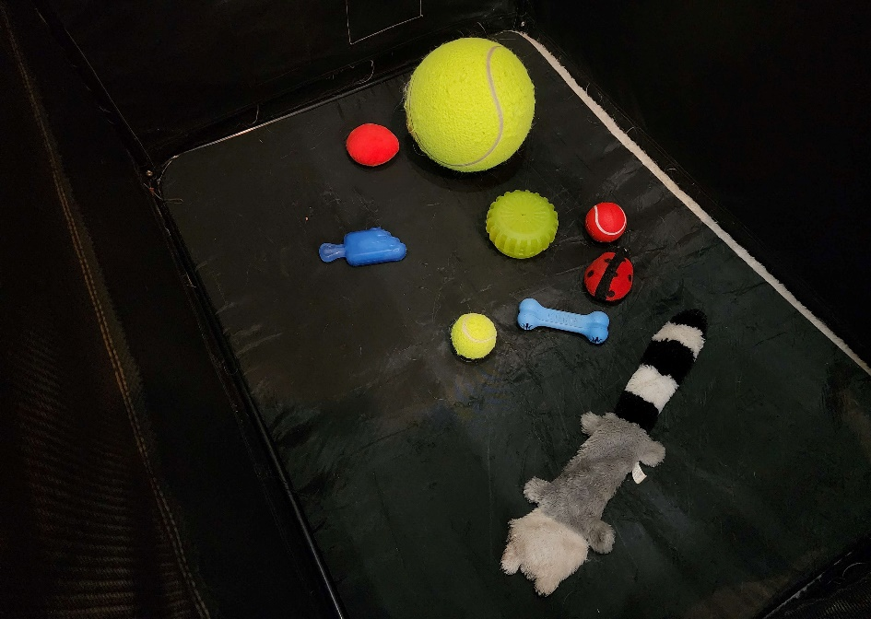

Top right Isometric:

Straight on:

Scene 2:

For this scene, we decided to go with a TV stand with various items ranging from straight to curved lines. I believe this will be a challenging image to portray in openGL while still maintaining a clean look.

Straight on:

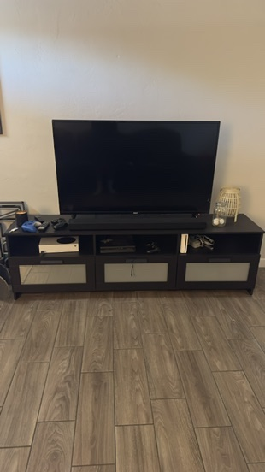

Scewed left:

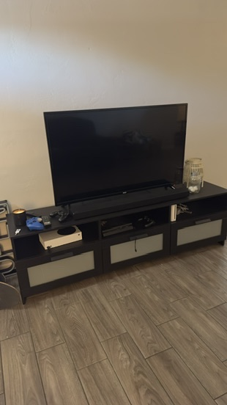

Skewed right:

